**Connection with Arduino and Sim900A GSM Module**

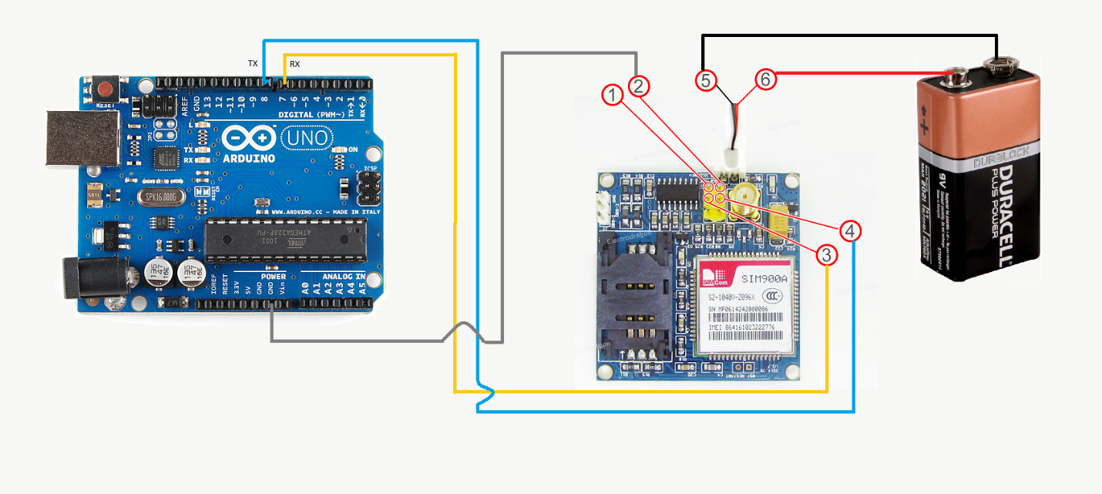

**Connections-**

1 to: No connection needed

2 to: GND of Arduino near 5V

3 to: Digital Pin 0 of Arduino (RX)

4 to: Digital Pin 1 of Arduino (TX)

5 to: GND (Digital GND near Pin 13)

6 to: 5V of Arduino

#include <SoftwareSerial.h>

int RST_PIN = 12;

SoftwareSerial gprsSerial(8, 9);

void setup(){

Serial.begin(9600);

Serial.print("Start ");

}

void loop(){

sendToServer();

}

void sendToServer() {

gprsSerial.begin(9600);

Serial.println("Config SIM900...");

delay(1000);

Serial.println("Done!...");

gprsSerial.flush();

Serial.println("1!...");

Serial.flush();

// attach or detach from GPRS service

gprsSerial.println("AT+CGATT?");

delay(100);

toSerial();

Serial.println("2!...");

// bearer settings

gprsSerial.println("AT+SAPBR=3,1,\"CONTYPE\",\"GPRS\"");

delay(500);

toSerial();

Serial.println("3!...");

// bearer settings

gprsSerial.println("AT+SAPBR=3,1,\"APN\",\"INTERNET\"");

delay(500);

toSerial();

Serial.println("4!...");

// bearer settings

gprsSerial.println("AT+SAPBR=1,1");

delay(500);

toSerial();

Serial.println("5!...");

gprsSerial.println("AT+HTTPINIT");

delay(1000);

toSerial();

String url = "http://picosoftbd.com/savedata.php?Data=Hello World";

Serial.println(url);

// set http param value

gprsSerial.println("AT+HTTPPARA=\"URL\",\""+url+"\"");

delay(2000);

toSerial();

// set http action type 0 = GET, 1 = POST, 2 = HEAD

gprsSerial.println("AT+HTTPACTION=0");

delay(5000);

toSerial();

// read server response

gprsSerial.println("AT+HTTPREAD");

delay(1000);

toSerial();

gprsSerial.println("");

gprsSerial.println("AT+HTTPTERM");

toSerial();

delay(500);

gprsSerial.println("");

delay(1000);

}

void toSerial()

{

while(gprsSerial.available()!=0)

{

Serial.write(gprsSerial.read());

}

}

void GSMRest() {

digitalWrite(RST_PIN, LOW);

delay(100);

digitalWrite(RST_PIN, HIGH);

}